Shane Mulqueen

**Overview**

Equity Markets became subject to rampant speculation during the late 1990’s as a result of valuations becoming more focused on future growth of earnings and less so on strong dividend payments to shareholders. This era from 1997-2000 deviated significantly from historical norms and desensitized investors to price volatility.

The stock market crash and recession from 2000-2002 are considered by many to have marked the end of this speculative “Dot-Com” bubble, with the correction of over-valued firms and failure of weak firms. However, equity markets have felt a lasting impact from this era- which may be highlighted below by the deviation from historical dividend yield.

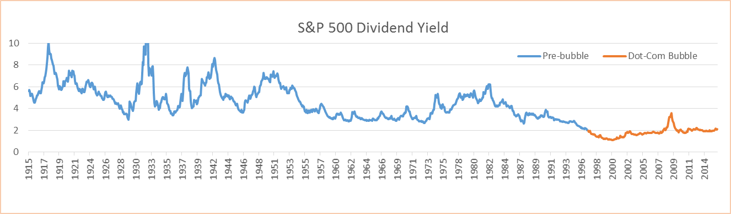

In collaboration with Ayasdi Inc. we have explored historical market returns to understand the lasting impact of this bubble in order to create insight for investment strategy and risk management.

**Data Set**

The analysis was conducted over the period 1966 through 2015 using daily log returns from 37 Industry Portfolios, the Fama/French 5 Factor Model, the S&P 500 Index, and 1, 5, and 10 year constant maturity US Treasury Rates.

From these returns, backward-looking 1, 2, 3 and 6-month returns and 3-month standard deviation of daily returns were calculated on a rolling window. These series were then divided by 12-month rolling window standard deviation to normalize the data and maximize comparability of different periods.

|  |  |
| --- | --- |
| **1966-1997** | **1998-Present** |
|  |  |

**Post Bubble Characteristics**

Volatility has increased substantially, and although the overall market return has seen an increase in risk adjusted return, the S&P 500 and many traditional sectors have not. This suggests that emerging industries- such as software, biotech, and renewable energy companies- have been the source of this outperformance.

In order to understand where the investor stands today, we will look at the distinct topological phases of this new market regime: the late 1990s bubble, subsequent crash and recession, 2000s housing bubble, financial crisis, and recovery.

**Late 1990s Bubble**

This period saw a 60% surge in market return over the risk free rate compared to the entire period. The strongest outperformance came from telecommunications, electronics, printing and publishing, food, retail and service industries.

Tobacco, oil, mining, precious metals, and leather industries did poorly.

Small cap companies were outperformed by larger cap, robust did not outperform weak, and high operating profitability firms were outperformed by low operating profitability firms.

Volatility surged in tobacco, food, chemicals, tv, and the service industries. The conservative minus aggressive and high minus low Fama-french factors became much less predictable as well.

**Bubble Crash**

Telecommunications, service, machinery, utilities, retail, and electronics saw a harsh reversal of their late 1990s trend.

Robust companies outperformed weak companies, and conservative portfolios outperformed aggressive portfolios. Small call companies outperformed large cap companies due to their tendency not to be affected as strongly by general market trends, especially higher PE ratio companies.

**Housing Bubble**

The housing bubble saw strength from industrial companies- oil, mining, petroleum and coal products, glass, and metals, and utilities.

**Fama-French Factors:**

* The excess market return over the risk free rate has increased, both in absolute terms and on a risk adjusted basis
* Value portfolios still outperform growth portfolios, but to a lesser degree
* Small cap portfolios have been consistently outperforming large cap portfolios to a greater degree
* Conservative portfolios have outperformed aggressive portfolios to a lesser and almost nonexistent extent
* Robust operating profitability firms have been outperforming weak operating profitability firms to a lesser extent

**Volatilities:**

* Rolling window 12 month standard deviation of daily returns have increased for nearly every single equity category
* Metal, glass & ceramics, mining, utilities, oil, construction, and textiles have increased the most, ranging from 50%-100%
* Some of the least affected industries include agriculture, food, tobacco, retail, service, and television
* 1 Year treasury volatility has decreased by 50%, 5 Year treasury volatility has decreased slightly, and 10 year treasury volatility has increased slightly

**Returns:**

* Most sectors included in this analysis have become less attractive investments
* Banking, Food, manufacturing, service, utilities and Oil have become much less attractive investments on both an absolute and a risk adjusted basis

**Conclusions**

Since the overall market return over the risk free rate has increased on both a risk adjusted and absolute basis, but the industry portfolios analyzed have decreased in performance, an outperformance must be attributed to firms not included in traditional sectors- which includes software and biotech firms. Breakthrough technology from the internet has placed into the public sphere rapidly growing firms that investors may not fully understand.

The promises of exponential growth these firms may or may not realize has made the market transition from seeking strong dividend yields to speculating on future growth. Firms are seeing increased scrutiny over quarterly earnings and forward looking statements from corporate leadership.

In the past a slight variance in revenue or earnings expectations may not produce much of a price reaction because this would not likely result in a change in dividend policy. Positive free cash flow firms could carry an excess amount of cash to insulate from short-term variability; a growth trend would need to persist for multiple quarters in order to change dividend policy.

Markets have historically sought strong dividend yields; this higher dividend yield prior to the dotcom bubble that can be seen above composed a much larger proportion of return and valuation. Because changes in dividend policy occur infrequently- annually or longer for most firms- changes in this component of total return occur less frequently which would result in lower price volatility.

Information sources during this era were also very limited, and so were tools to drive fundamental understanding from large datasets. Therefore, statements from corporate employees were of greater importance.

The internet bubble created firms with rapid revenue growth that reinvested operating cash-flows to continue this expansion. Current profitability was not a factor in the valuation of these firms- substantial future earnings seemed inevitable by sustained revenue growth and the presumption that reinvestment of cash-flows would plateau and grow the balance sheet. Valuations became heavily dependent on future growth, and incremental releases of new information grew in importance. Forward looking valuation models depend heavily on quarterly results; a miscue of just a few percent compounds exponentially with five or ten years of forward looking growth being priced in.

The insulation of a steady cash stream to investors was nonexistent for these high growth firms in emerging industries, and became eroded for firms that were able to do so. After PE multiples expanded in the 1990’s, the S&P 500 has dipped below the average ratio from 1950-present only one. This shrank the dividend yield component of total return that firms could use to reduce price volatility, and consequently put these firms under the same microscope that high growth firms in emerging industries were under.

The consequence of this earnings multiple expansion and markets speculating on future growth has been an increase in volatility.

For investors this means that the ability to forecast earnings has become increasingly important for managing portfolio risk. Even with a long-term investment horizon, a fund manager may be able to control risk by temporaily reducing positions in companies that will likely miss earnings expectations. This requires the analysis of alternative data sources that have more timeliness that quarterly earnings; massive information system infrastructure improvements will enable this.

While this market regime persists long equity strategies should seek high returns through aggressive strategies that have increased exposure to smaller cap technology firms that have not yet achieved mature and robust profit streams.

|  |  |
| --- | --- |
| Standard deviation of daily S&P 500 Daily Returns: 1 year Rolling window | S&P 500 Dividend Yield |
|  |  |